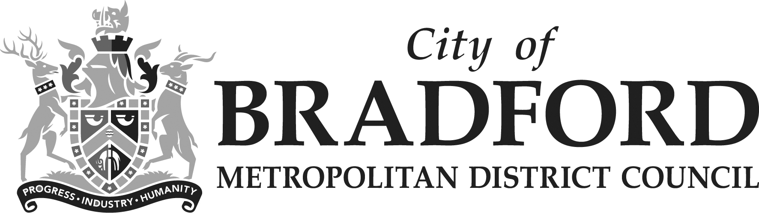

Equality Impact Assessment Form Reference: A5-7

Department | Place | Version no | 0.2
Assessed by | Nic Greenan | Date created | 28/11/23
Approved by |  | Date approved
Updated by |  | Date updated
Final approval |  | Date signed off

The Equality Act 2010 requires the Council to have due regard to the need to
- eliminate unlawful discrimination, harassment and victimisation;
- advance equality of opportunity between different groups; and
- foster good relations between different groups.

Section 1: What is being assessed?

  - Name of proposal to be assessed.

Review of Cultural Grant Funding

1.2 Describe the proposal under assessment and what change it would result in if implemented.

The proposal is to reduce the annual grants & strategic investment programmes in cultural activity in the sector.

The proposal is to reduce large and small grant funding from £166,500 by £79,100 resulting in a saving of £87,400.

The reduction would result in removing Council cultural grant support for community organisations across the district to access funds to deliver locally run cultural activity. These grants are part of enabling the delivery of our key ambitions for Culture Is Our Plan, ‘Creative thrives in every street corner’.

Section 2: What the impact of the proposal is likely to be

  - Will this proposal advance equality of opportunity for people who share a protected characteristic and/or foster good relations between people who share a protected characteristic and those that do not? If yes, please explain further.

No.

  - Will this proposal have a positive impact and help to eliminate discrimination and harassment against, or the victimisation of people who share a protected characteristic? If yes, please explain further

No.

  - Will this proposal potentially have a negative or disproportionate impact on people who share a protected characteristic? If yes, please explain further.

This proposal may have a negative / disproportionate impact on people who are less able to access arts, culture & heritage as all the funding programmes are aimed to work with & support our most marginalised and disadvantaged communities where there are more residents on low income. There may also be impact on disabled and older residents in being able to access programmes in local communities. The communities which the grants focus on also include those where there are high numbers of residents from ethnically diverse backgrounds.

  - Please indicate the level of negative impact on each of the protected characteristics?

(Please indicate high (H), medium (M), low (L), no effect (N) for each)

Protected Characteristics: | Impact  (H, M, L, N)
Age | N
Disability | N
Gender reassignment | N
Race | M
Religion/Belief | N
Pregnancy and maternity | N
Sexual Orientation | N
Sex | N
Marriage and civil partnership | N
Additional Consideration:
Low income/low wage | M
Care Leavers | N

2.5 How could the disproportionate negative impacts be mitigated or eliminated?

The team will put more emphasis on working with the sector to raise further funds to ensure they reach those with protected characteristics. In addition, the grants programme for City of Culture 2025 will be offering grants to organisations to enable the delivery of cultural activities which will ensure that cultural activity continues in all communities including those targeted through this grants programme.

Section 3: Dependencies from other proposals

3.1 Please consider which other services would need to know about your proposal and the impacts you have identified. Identify below which services you have consulted, and any consequent additional equality impacts that have been identified.

These changes have been shared with Children’s and Adult Services due to potential impact on vulnerable adults and children.

The Cultural Place Partnership is the strategic board that feeds into the Wellbeing Board that aligns all our stakeholders, many of the grants they make are in partnership with BMDC. If there was any change to our investment, we would inform them as part of funding agreements.

There are also a number of funders who would need to be informed. These include the Arts Council, DCMS, Heritage Lottery Fund and WYCA

Section 4: What evidence you have used?

4.1 What evidence do you hold to back up this assessment?

There has been a review of grants distributed and the work planned through City of Culture.

4.2 Do you need further evidence?

None currently identified.

Section 5: Consultation Feedback

5.1 Results from any previous consultations prior to the proposal development.

None

5.2 The departmental feedback you provided on the previous consultation (as at 5.1).

None

5.3 Feedback from current consultation following the proposal development (e.g. following approval by Executive for budget consultation).

Consultation not carried out yet.

5.4 Your departmental response to the feedback on the current consultation (as at 5.3) – include any changes made to the proposal as a result of the feedback.

Consultation not carried out at this stage, this will be reviewed based on the consultation feedback which will be considered, and in particular any disproportional impact that potentially could be experienced by any protected characteristic group.

